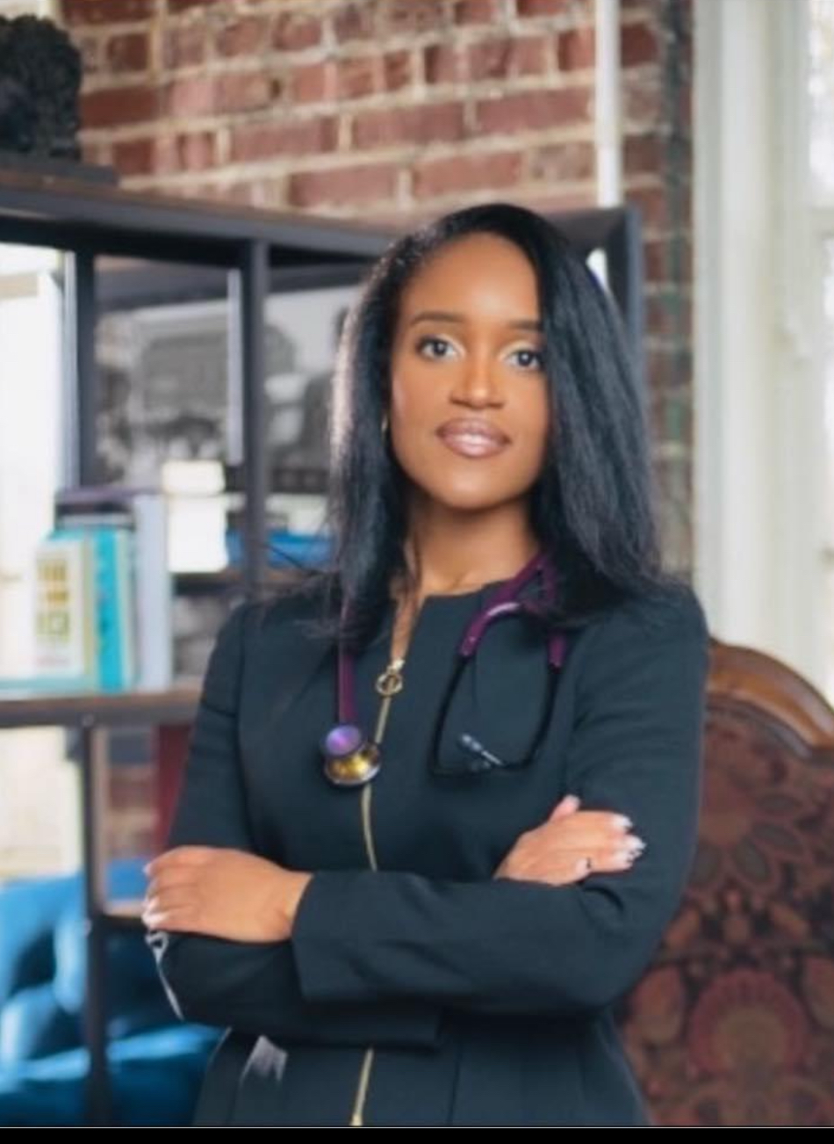
DOMINIQUE’ J. CRAIN, M.D.
P.O. Box 2066
Alpharetta, GA 30023
Mobile: (470)-491-4328
djclocums@gmail.com

JANUARY 2026

Founder and CEO of Dominique Crain Locums and Medical Legal Consulting LLC (Formerly Dominique Crain Locums LLC). Clinically active board-certified Family Medicine physician with a primary focus in high acuity hospital medicine as a hospitalist. Current experience in multiple hospital settings in multiple states. Prior experiences in primary and urgent care settings among other states. Former affiliated staff member of Stanford University. Former elected GA Top Doc 2021.

HOSPITAL AND HEALTH CARE ORGANIZATION AFFILIATIONS
Piedmont Eastside Hospital, Lawrenceville, GA (2024-present)
Locums Nocturnal physician hospitalist
I serve as an attending hospitalist and nocturnist responsible for the overnight evaluation, admission and management of acutely ill adult patients presenting from emergency departments and outside transferring facilities. I urgently respond to acutely decompensating patients in the evening and early morning hours; sometimes necessitating running emergent lifesaving measures such as code blues.

Emory University Hospital, Johns Creek, GA (2024-present)
Locums Nocturnal Physician Hospitalist; Hospital Medicine
I serve as the mid-shift admitting attending hospitalist assessing and admitting patients from the ED and I accept transfers from outside facilities.
Norton Audubon Hospital, Louisville, KY (2024-present)
Locums Attending Physician Hospitalist; Hospital Medicine
I serve as an attending hospitalist responsible for the admission, evaluation, and management of acutely ill adult patients presenting from the emergency department, transferring facilities, and outpatient settings. I provide evidence-based medical care to patients in the medical-surgical, intermediate/step-down and intensive care units. I implement medical decision-making regarding the necessity in escalation of care, interfacility transfer, and discharge planning based on patient condition and facility capabilities. I also provide hospice services in collaboration with hospice specialists for terminally ill patients’ end of life care to assure their remaining moments are as pain-free and comforting as medically possible; all while providing supportive measures for their loved ones.
North Knoxville Medical Center, Knoxville, TN (2024-present)
Locums Nocturnal physician hospitalist; Hospital Medicine
Responsibilities include admission and management of acutely ill patients from the emergency room, outside transferring facilities or direct admissions from outpatient facilities. I admit to the medicine-surgical unit, intermediate/step down unit and ICU. I respond to acutely decompensating patients in the units; sometimes necessitating emergent lifesaving interventions such as code blues.
University of Alabama Providence Hospital, Mobile, AL (2023-2024)
Attending Hospitalist Physician; Hospital Medicine
Overall responsibility to admit and manage acutely ill patients from emergency room, transferring hospitals and direct admissions from outpatient facilities. I provided evidence based medical care to patients in med-surgical units, intermediate/step down units and ICU. Other responsibilities included outbound transfers and discharges after completion of medical management within the capabilities of the facility.

Piedmont Urgent Care, Atlanta, GA (2021-2024)
Locums Attending physician, Family Medicine
Provide medical management for varying minor acute illness and/or injuries in a clinical setting. Formulation of diagnostic conclusions and immediate treatments in efforts to facilitate the patients’ safe and immediate return to their daily lives and families. Delineate cases that warrant an escalation in care and execute a safe and efficient transfer of care to a higher acuity treatment facility.
Stanford University Healthcare, Emeryville, CA (2022-2023)
Locums Attending physician, Family Medicine
Provide guideline based preventative medical care to patients in a clinical setting. Address ongoing chronic conditions in efforts to improve the quality of life and promote the overall health of patients and the local community.
Kahlihi Palama Health Center, Honolulu, HI (2022)
Locums Attending Physician, Family Medicine
Provide guideline based preventative medical care to local and native communities on the island of Oahu. I helped manage and treat chronic medical conditions often not appropriately manage due to limitations in access to care. I collaborated with social services and case management to address social determinants of health that hindered patients from reaching their peak health.
Peachtree Immediate Care, Atlanta, GA (2021)
Locums Attending Physician, Family Medicine
I provided urgent immediate services for minor acute illnesses and injuries. Procedures include but not limited to laceration repairs, splinting, incision & drainage. As mentioned above, I formulated diagnostic conclusions in immediate settings often delineating what warranted escalation of care. I communicated with respective staff at nearby hospitals and EMS to execute a safe and seamless transfer for the patient.

EDUCATION
University of South Alabama College of Medicine, Mobile, AL 2013-2017
Doctor of Medicine
University of South Alabama, Mobile, AL 2008-2012
Bachelor of Arts and Sciences

POST-DOCTORAL TRAINING
University of Alabama Family Medicine Residency Program, Tuscaloosa, AL 2018-2020
Resident Physician
University of Alabama Family Medicine Residency Program, Tuscaloosa, AL 2017-2018
Intern Physician

LICENSURES AND CERTIFICATIONSS
American Board of Family Medicine (2020)
Diplomate
Alabama Board of Medical Examiners & Medical Licensure Commission (2017)
Unrestricted Medical license
Medical Board of California (also Osteopathic Medical Board of California) (2022)
Unrestricted Medical license
Georgia Composite Medical Board (2020)
Unrestricted Medical license
Illinois Department of Professional Regulation – Medical Licensing Board (2024)
Unrestricted Medical license
Kentucky Board of Medical Licensure (2025)
Unrestricted Medical license
Louisiana State Board of Medical Examiners (2024)
Unrestricted Medical license
Minnesota Board of Medical Practice (2024)
Unrestricted Medical license
Nevada State Board of Medical Examiners (2024)
Unrestricted Medical license
State Medical Board of Ohio (2024)
Unrestricted Medical license
Pennsylvania State Board of Medicine (2024)
Unrestricted Medical license
Tennessee Board of Medical Examiners (2023)
Unrestricted Medical license
Texas Medical Board (2023)
Unrestricted Medical license
Advanced Cardiac Life Support Certification Recurrent
Basic Life Support Certification Recurrent
Pediatric Advanced Life Support Certification Recurrent
Advanced Trauma Life Support Certification Recurrent

HOSPITAL OR AFFILIATED INSTITUTIONS
Piedmont Eastside Hospital, Lawrenceville, GA
Locums physician
Piedmont Walton Hospital, Snellville, GA
Locums physician
Emory University John’s Creek Hospital, John’s Creek, GA
Locums physician
Emory University St Joseph’s Hospital, Atlanta, GA
Locums physician
Emory University Hospital Decatur, Decatur, GA
Locums physician
Norton Audubon Hospital, Louisville, KY
Locums physician
North Knoxville Medical Center, Knoxville, TN
Locums physician
Tennova Turkey Creek Medical Center, Knoxville, TN
Locums physician
University of South Alabama Providence Medical Center, Mobile, AL
Associate physician
Stanford University Health System, Emeryville, CA
Locums physician

Stanford University Health System, Alameda, CA
Locums physician
Kalihi Palama Health System, Honolulu, HI
Locums physician

PROFESSIONAL SOCIETIES
Atlanta Medical Association
Medical Association of Atlanta
Society of Hospital Medicine
American Medical Association
National Medical Association
American Academy of Family Physicians
Georgia Academy Family Physicians

AWARDS AND HONORS
Elected Georgia Top Doc 2021 2021
North Atlanta East Primary Care Physician Rookie of the Year 2021
University of Alabama Family Medicine Residency Resiliency Award-Recognition of volunteerism, dedication and courage working frontlines of COVID-19 Pandemic 2020
University of South Alabama H.C Mullins M.D. Award in Family Medicine 2017
Leadership Award for Dedication and Commitment, Student National Medical Association 2017
Leadership Award for Dedication and Commitment, Student National Medical Association 2016
Most Compassionate Award, University South Alabama College of Medicine Diversity Recruitment/Enrichment for Advancement into Medicine (D.R.E.A.M) Program 2011
Most Compassionate Award, University South Alabama College of Medicine Diversity Recruitment/Enrichment for Advancement into Medicine (D.R.E.A.M) Program 2010

PRESENTATIONS/PROJECTS/RESEARCH
Medical/Legal Practice Enhancement with Medical Resident Engagement, University of 2020
Alabama
Medical Student Summer Research Program 2013
Preceptors: Mikhail Alexeyev, Ph.D, Robert Barrington Ph.D
Hypothesis: Mitochondrial DNA damage-mediated effects on Macrophages. Damage to mtDNA leads to a release of extracellular damage-associated molecular patterns (DAMPs) and ultimately an increased pro-inflammatory response with release of cytokines.
Role: Cell culture, western blot assays, flow cytometry, ELISA, qPCR, viral transduction

